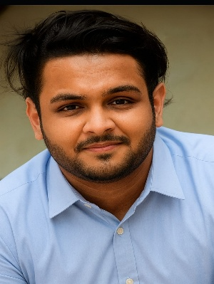 |  |  |  |  | bhavesh sethi  - DU , SOL| +919650622582| ADDRESS : 9/62 (A) 2ND FLOOR, 9 BLOCK MOTI NAGAR | bhaveshsethi0business@gmail.com  Motivated and confident graduate with excellent communication and leadership skills, seeking an entry-level call centre position. Eager to provide high-quality customer service, resolve issues effectively, and contribute to team success. Strong ability to connect with people and manage conversations with professionalism and empathy.

education
June 2016 |  |  |  | 91Cbse 10th  Secured 60.8% in class 10th
JuLY 2019 |  |  |  | class 12th  Secured 58.8% in class 12th  university of delhi (sol)  Was awarded with degree Graduated in 2023 in B.A

proffesional experience
Fresher (Eager to apply knowledge and interpersonal skills in a professional call center environment)
Skills |  |  |  |  |  |  | Activities
- Strong Communication Skills  - Leadership Abilities  - Persuasive & Convincing Nature  - Active Listener  - Team Player  - Customer-Focused Approach  - Basic Computer Knowledge  - Quick Learner |  |  |  |  |  |  | - Reading  - Acting

